# **Rapport Document**

## **For 13/12/2022 :**

### **Done :**

- Creation specification Document – PA/Dylan/Matis

- Creation Backlog Document – PA

- Modification Activity Diagrams/Sequency Diagrams/Use Case Diagrams – PA/Dylan/Matis

### **To Do :**

- Discution about the architecture document

## **For 04/01/2023 :**

### **Done :**

- Creation New Domain Class Diagram – PA

- Update documentation document - PA

### **To Do :**

- Discution about the architecture document

## **For 11/01/2023 :**

### **Done :**

- PA has created a new activity diagram fir the login part, it was asked my Mr.Ferry. This diagram has been added to the specification document – PA

- Dylan has upgraded the handle health data activity diagram by specifying the user and the timestamp to select to see the data, it was asked my Mr.Ferry. This diagram has been added to the specification document – Dylan

- Matys added all his diagrams and his part (handle personal circle) on the specification document – Matys

- We created a new developpement board on Github with all the task to do to make 2 of our use case which are the login/register use case and the Handle health data. – PA/Dylan/Matys

- We created a new non-developpment board on Github with all the task to do about non development task like for the documents – PA/Dylan/Matys

### **To Do :**

## **For 11/01/2023 :**

### **Done :**

- PA has updated the sequence diagrams of the UC1 – Authentication to add exceptions – PA

- PA has created a product owner report on excel – PA

- Dylan updated the sequence diagram of the UC2 - Examine Health Data to add the interface – Dylan

- Dylan has created the scrum master report on excel – Dylan

### **To Do :**

* Make the new sprint board for the 1st sprint

### **Product Owner Report :**

### **Scrum Master Report :**

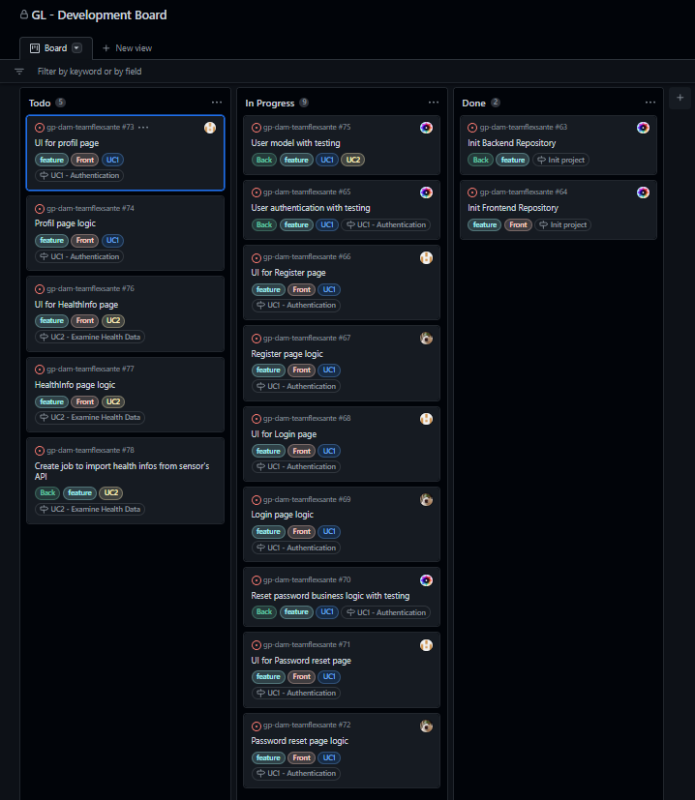

## **For 24/01/2023 :**

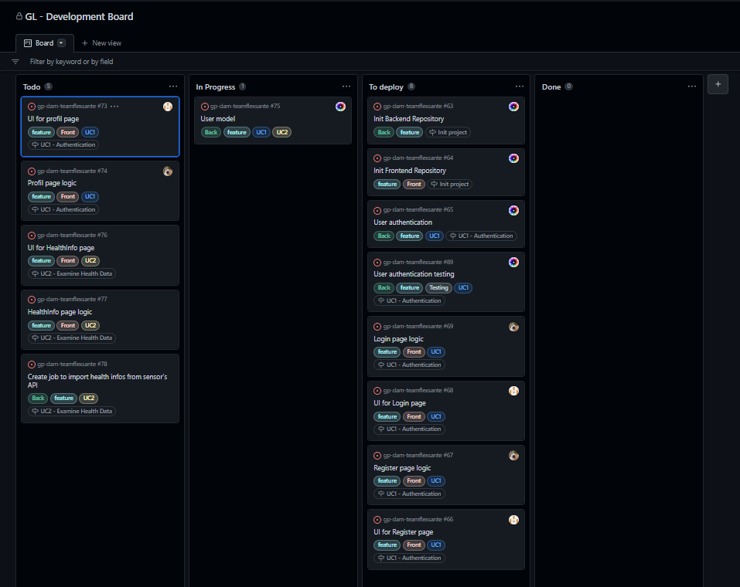

### **To Do :**

* Sprint UC2
* Update Workflow